**G. L. A. UNIVERSITY, MATHURA, U. P.**

**Institute of Engineering & Technology**



**MINI PROJECT-II**

**(2020-21)**

**Project Report: CodeHound**

**Submitted By: Submitted to:**

Muskan Upadhyay (181500407) Faculty: Akash Kumar Chaudhary

Abhinav Chaudhary (181500010)

Kushagra Dubey (181500345)

Shobhit Chaturvedi (181500685)

Tejasv Singhal (181500757)

**ACKNOWLEDGEMENT**

It is great pleasure for us to undertake this project. We feel highly doing the project entitled – “CodeHound”.

We would like to express our special thanks of gratitude to our project mentor **Mr. Akash Kumar Chaudhary** who gave us the golden opportunity to do this wonderful project, which also helped us in doing a lot of research and we came to know about so many wonderful things.

We would like to thank the faculties and whole staff of GLA University who helped us to increase our knowledge and skills.

Secondly, we would like to thank our parents and friends for their constant support.

**DECLARATION**

We hereby declare that the work which is being presented in the Mini project **“CodeHound”**, submitted by us to **Department of Computer Engineering and Applications, GLA University, Mathura** - 281006 in partial fulfillment of the requirements for Mini project viva voce, is an authentic record of our own work carried under the guidance of our supervisor “Mr. Akash Kumar Chaudhary”. I further declare that the work reported in this project has not been submitted and will not be submitted, either in part or in full, for the award of any other degree or diploma in this university or any other institute or university.

**Team Members:**

Muskan Upadhyay (181500407)

Kushagra Dubey (181500345)

Abhinav Chaudhary (181500010)

Tejasv Singhal (181500757)

Shobhit Chaturvedi (181500685)

Course: B. TECH CSE, 3rd yr.

**INDEX**

|  |  |
| --- | --- |
| S.NO | Topic |
|  | Abstract |
|  |  |
| 1 | Introduction |
|  |  |
| 2 | Motivation and Objective |
|  |  |
| 3 | Problem Statement |
|  |  |
| 4 | Modules & their functionalities |
|  |  |
| 5 | Software Design |
|  |  |
| 6 | Coding the web |
|  |  |
| 7 | Testing |
| 8 | References |

**INTRODUCTION:**

**1.1 General Introduction to the topic**

Proposed **CodeHound** is a platform for learning Competitive Programming virtually, while practicing to code simultaneously. Programmers who want to learn Competitive Programming from the basic to high level, can visit the web portal and find extremely useful tutorials. While landing the web page, an introduction video of ‘What is Competitive Programming’ can be seen by the viewers. We have the search logo to search the topics programmers wants to learn. Proposed web portal also has the tutorial videos too along with the study material for every topic.

CodeHound also have its own compiler. As we know, learning without practicing is of no use. The compiler will compile the code in various languages such as C++, Java, Python etc. A lot of big companies like Google, Facebook. Microsoft, Amazon hires through competitive programming so to get into these companies then we really need to have strong hands in competitive programming. It doesn’t matter that someone is a newbie programmer or have written some code before, we will tell some steps, approaches, and tips to prepare themselves for competitive programming.

The tutorial videos & written material will help the students to learn competitive programming in a best manner, and by practicing their hands on in any of their favorite programming language, all these things will make our efforts of making this website successful.

**1.2 Introduction of Technology**

* **React.js:**

React is a library for building composable user interfaces. It encourages the creation of reusable UI components, which present data that changes over time. Lots of people use React as the V in MVC. React abstracts away the DOM from you, offering a simpler programming model and better performance. React can also render on the server using Node, and it can power native apps using React Native. React implements one-way reactive data flow, which reduces the boilerplate and is easier to reason about than traditional data binding.

* **HTML5:**

HTML5 is the latest and most enhanced version of HTML. Technically, HTML is not a programming language, but rather a markup language. **HTML** stands for **Hyper Text Markup Language.** It is a formatting language used to define the appearance and contents of a web page. It allows us to organize text, graphics, audio, and video on a web page.

* **CSS3:**

Cascading Style Sheets, fondly referred to as CSS, is a simply designed language intended to simplify the process of making web pages presentable. CSS allows you to apply styles to web pages. More importantly, CSS enables you to do this independent of the HTML that makes up each web page.

* **Bootstrap 4**: Bootstrap is a free and open-source tool collection for creating responsive websites and web applications. It is the most popular HTML, CSS, and JavaScript framework for developing responsive, mobile-first web sites. It solves many problems which we had once, one of which is the cross-browser compatibility issue.
* **JavaScript**: JavaScript is a lightweight, interpreted programming language. It is designed for creating network-centric applications. It is complimentary to and integrated with Java. JavaScript is very easy to implement because it is integrated with HTML. It is open and cross-platform. JavaScript is the most popular programming language in the world and that makes it a programmer’s great choice. Once you learnt JavaScript, it helps you developing great front-end as well as back-end softwares using different JavaScript based frameworks like jQuery, Node.JS etc.

**Motivation & Objective:**

The reason or motivation behind selecting this project is to teach & help others who wish to become a master in competitive programming. Many of times it happens that people don’t get the tutorials given on youtube or they don’t easily understand or get comfortable with the way of teaching. Some likes to study from watching videos, some likes to learn by reading tutorials or books & some likes side by side practicing to code. Therefore, we are providing everything including reading tutorials, tutorial videos & a compiler too to practice your hands on!

Another reason is that a lot of big companies like Google, Facebook. Microsoft, Amazon hires through competitive programming so to get into these companies then we really need to have strong hands in competitive programming. It doesn’t matter that someone is a newbie programmer or have written some code before, we will tell some steps, approaches, and tips to prepare themselves for competitive programming.

If you are a programmer you might have understood the deep meaning of these lines quoted by Steve Jobs and you might have also experienced that even after shutting your computer you keep on thinking about programming stuff or code you have written in your project. Once you enter in programming you just don’t learn how to code but you also learn the “art of thinking”, by breaking your code into smaller chunks and then using your logic-based creativity to solve a problem from different angles.

Programming is fun, programming is an exercise for your brain, programming is a mental sport and when this sport is held over the internet involving sport programmer as a contestant then it is called ***Competitive Programming***.

It doesn’t matter that someone is a newbie programmer or have written some code before, we will tell some steps, approaches, and tips to prepare themselves for competitive programming.

We will provide a compiler to practice your hands on in programming & helps you to be a coding master!

The website will include tutorial videos including written material too. What else is needed to be a pro in coding!

**Future Scope:**

* A lot of big companies like Google, Facebook. Microsoft, Amazon hires through competitive programming so to get into these companies then we really need to have strong hands in competitive programming.
* Learners can learn from the website whenever & wherever they want to. They can watch tutorial videos of ours or can read the written material or practice their hands on the compiler we are providing.
* The website will prove to be very helpful in future, not just for those who are preparing for placements but also who are newbie programmers & doesn’t have any idea of competitive programming.

**What Contributions would the project make and where?**

* Individuals who visit the website will Learn & have experience in programming.
* The more recognition will website gain, the more people will get the benefit.
* Easy availability of everything including written material, tutorial videos & compiler.
* Learning & practicing anywhere, anytime with just an Internet connection & a device.

**Problem Statement:**

* What is Competitive Programming and How to Prepare for It?
* **Teaching the Concept of Time and Space Complexity.**
* **Choosing the Programming Language.**
* **Explaining the Fundamentals of Data Structures and Algorithms.**
* **Take the Challenge and Solve Coding Problems.**
* **Motivate students for Practicing and Do it Regularly.**

**Modules and their Functionalities:**

**Registration module –** In this module, user can submit details and obtain the username and password for login.

**Login Module –** In this module, user can enter the details by providing username and password.

**About us module –** User can see the description of the website.

**Nav Bar module –** User can study various topics of competitive programming such as Number Theory, Trees, Arrays, Graph Theory, Dynamic Programming etc.

**Tutorial Videos –** User can see videos for various topics for better learning and understanding.

**Software Design:**

**Hardware and Software Requirements**

**System Requirements:**

***Supported Operating system:***

Windows 10 Windows 8 Windows 7

***Software Required:***

* Visual Studio Code – It is a source code editor developed by Microsoft for Windows, linus and macOS.
* Chrome – It is a web browser.
* Technologies Implemented:
* HTML - For user interface.
* CSS - For making interfaces more attractive and stylish. This will help us with the layout control.
* JavaScript - Gives web pages interactive elements that engage a user.
* React js - React is a open source JavaScript library that is mostly used to build single pages user interfaces application. It is used to handle the view for the website and mobile apps. It is very important as it gives us the reusability of the UI component.
* MongoDB – It is a document database with the scalability and flexibility that you want with the querying and indexing that you need.

***Hardware Requirements:***

* Processor: intel i5
* Operating System: Windows 10
* RAM: 8GB
* Hardware Devices: Computer System
* Hard Disk**:** 256 GB
* Internet Connection

**Data Flow Diagram:**

Data Flow diagrams show the flow of data from external entities into the system, and from one process to another within the system.

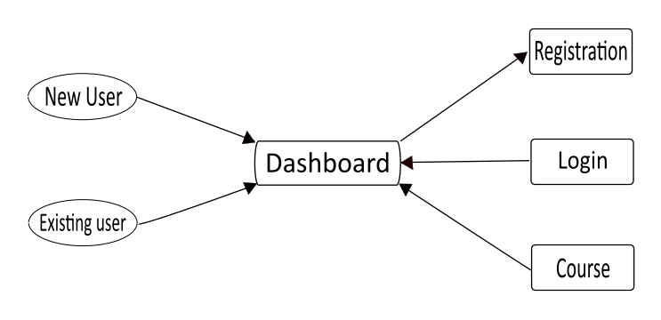

**Level -0 Diagram:**

The level 0 diagram provides a conceptual view of the process and its surrounding input, output and data stores. It is called context level Data flow diagram also.

**Coding the web:**

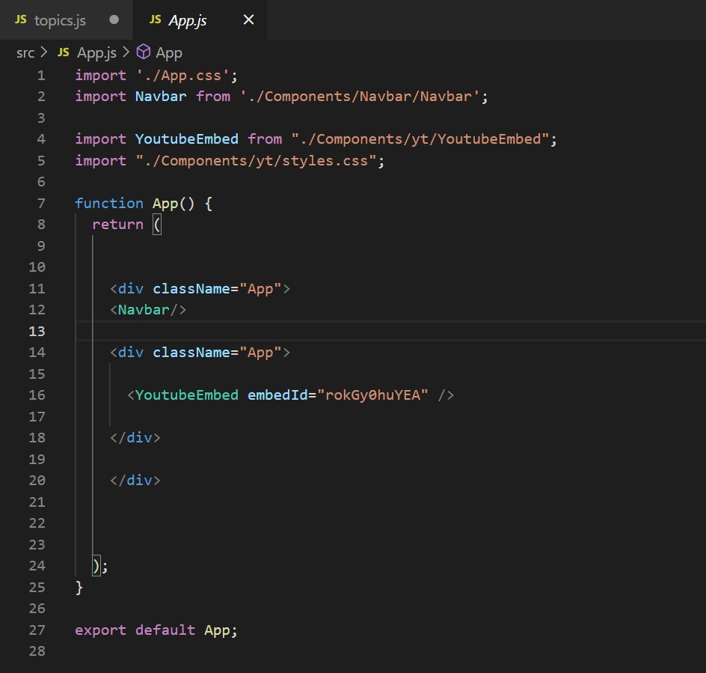

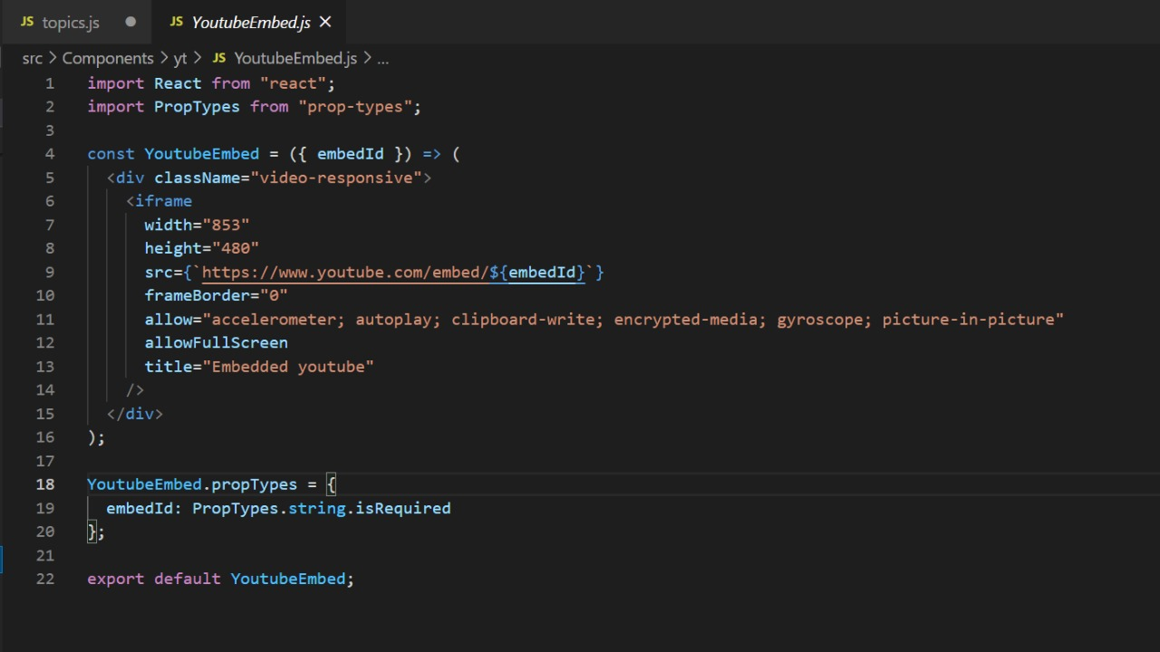

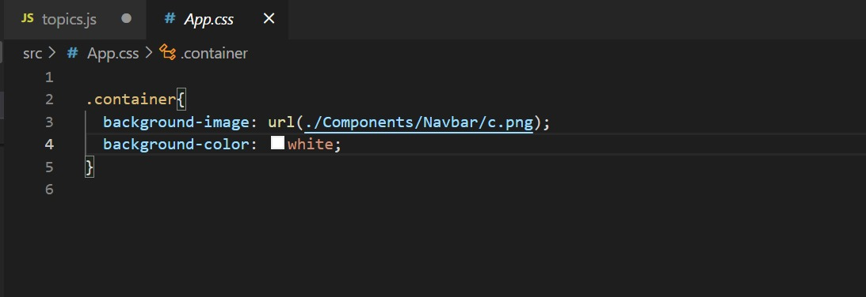

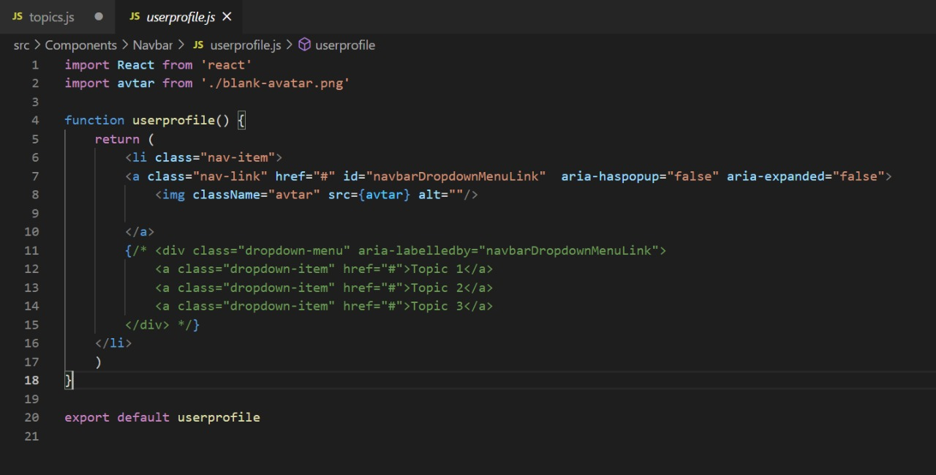

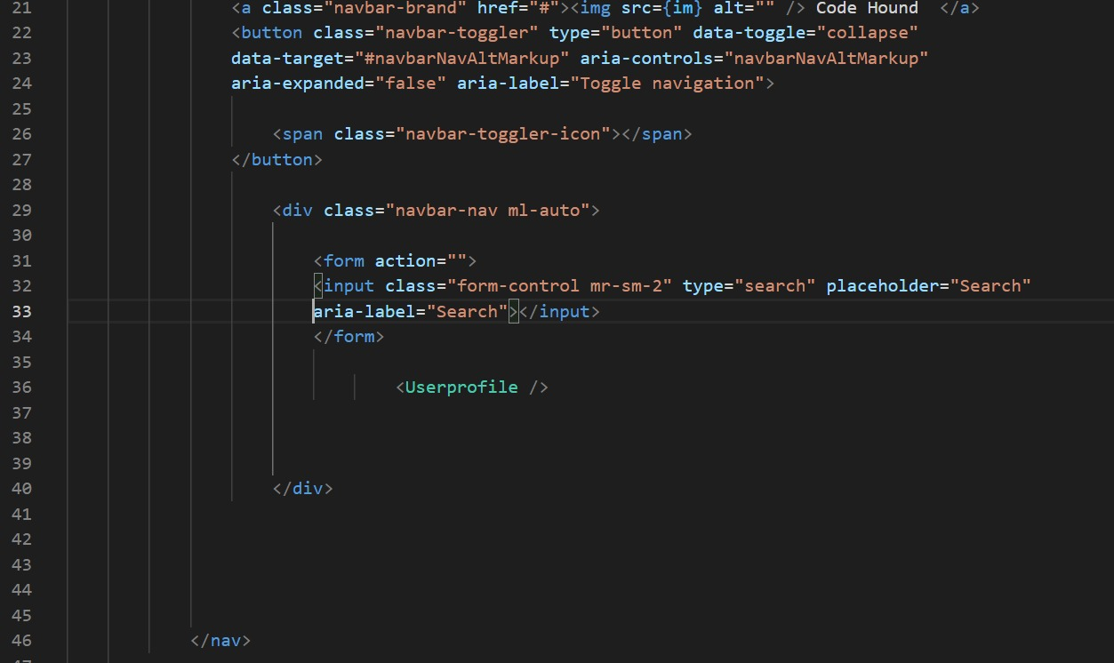

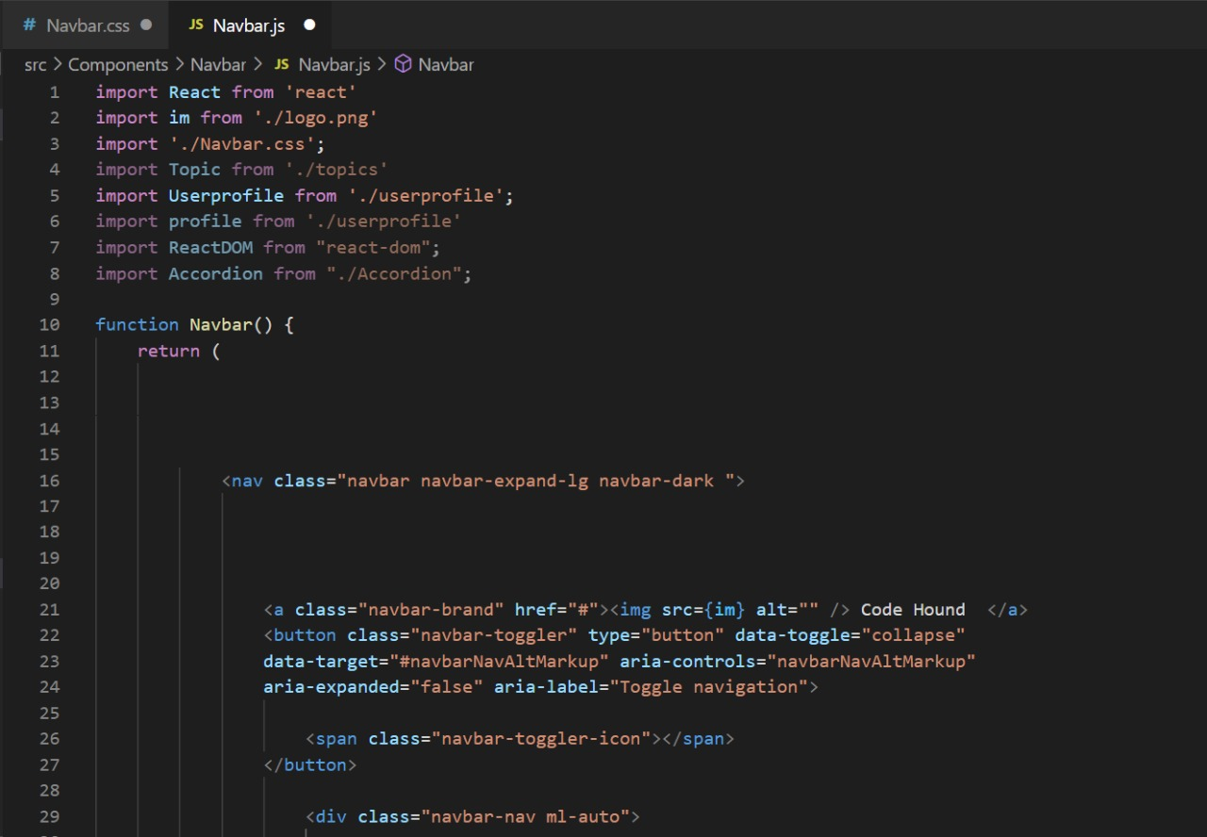

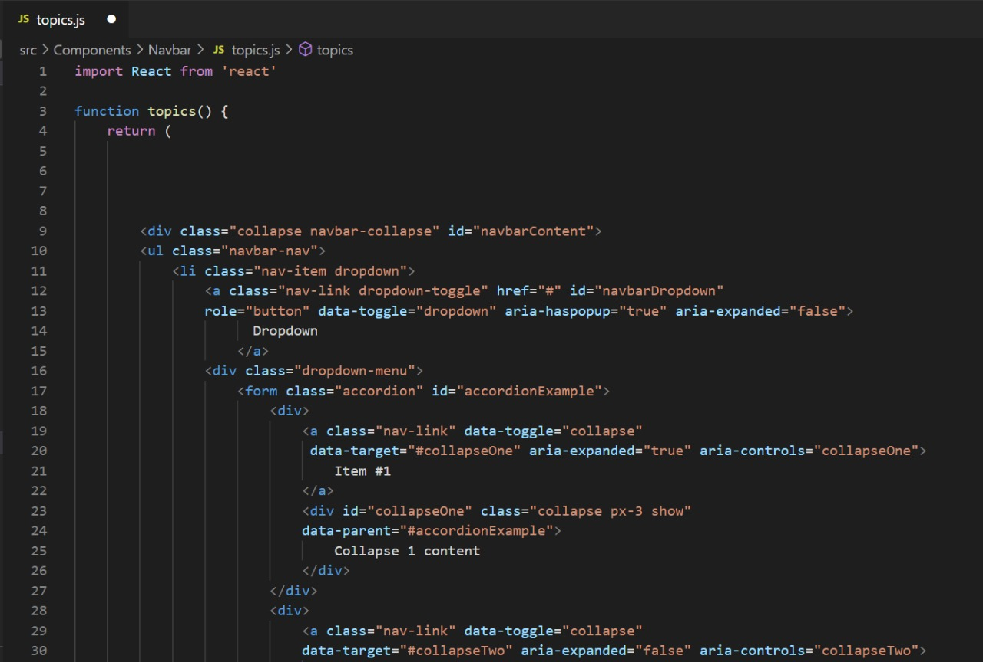

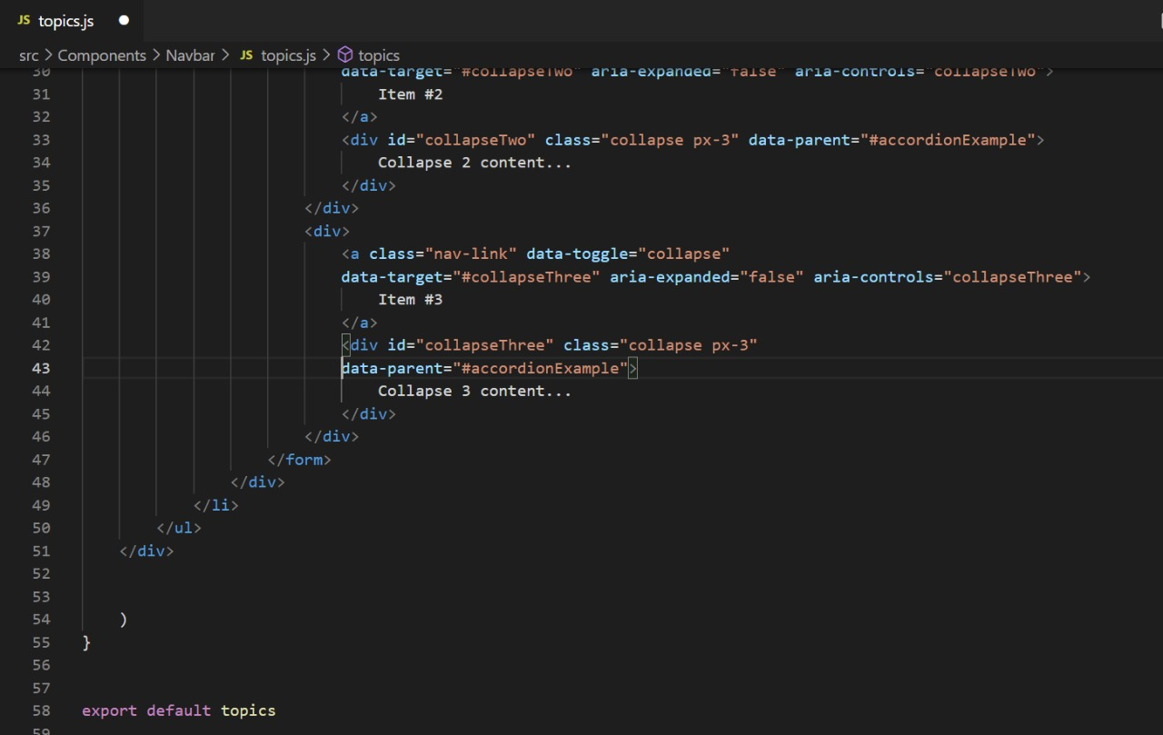

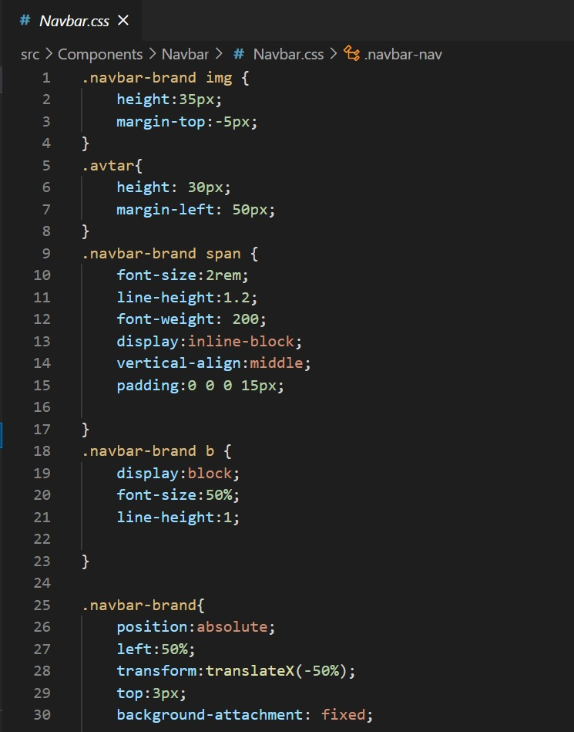

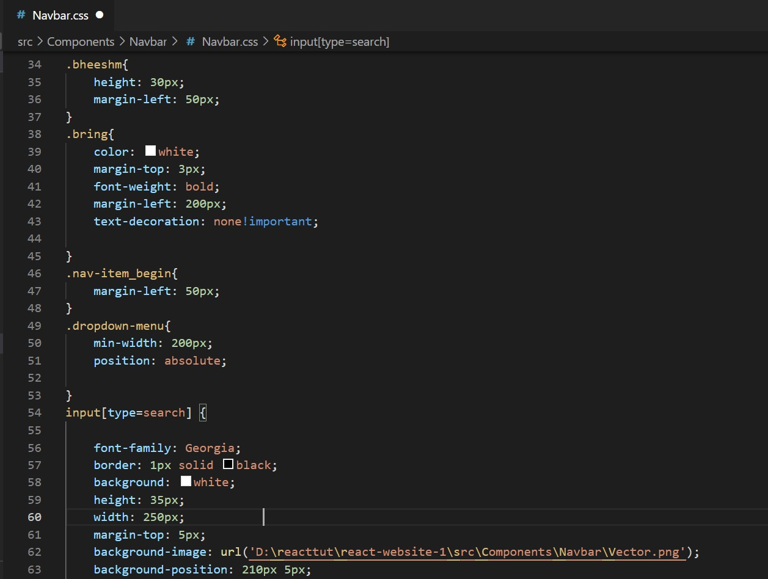

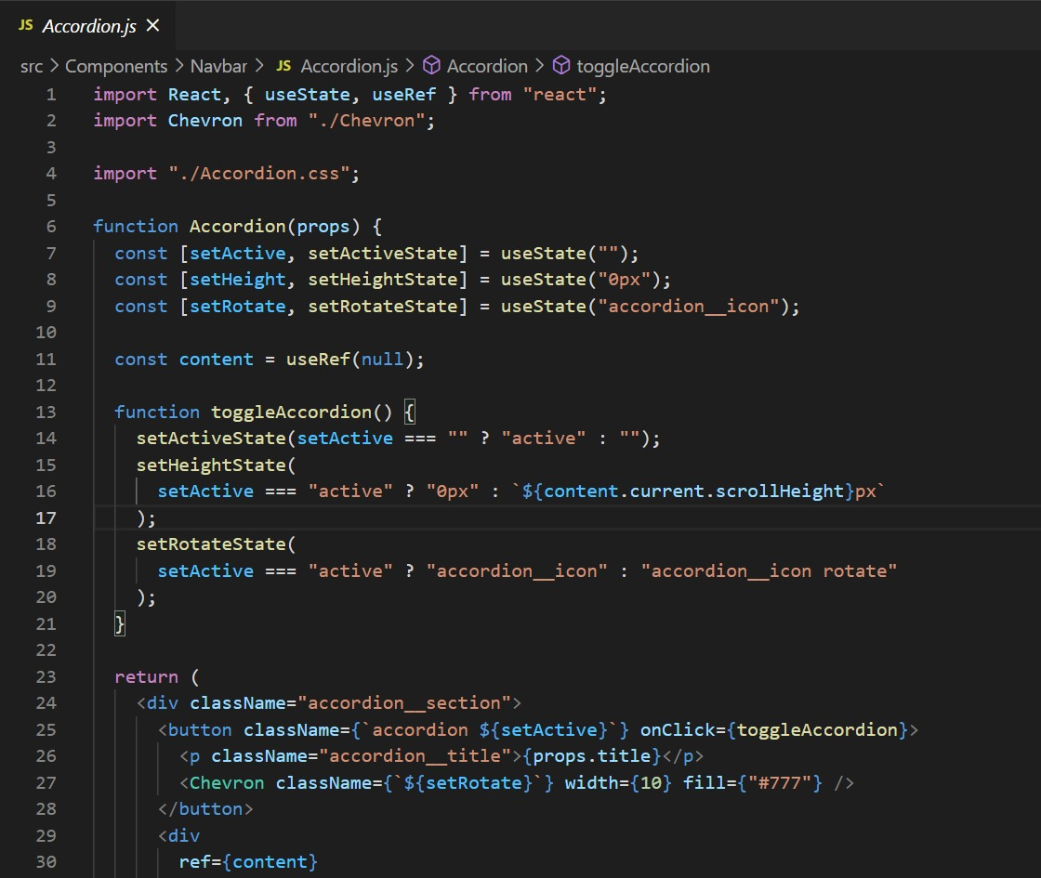

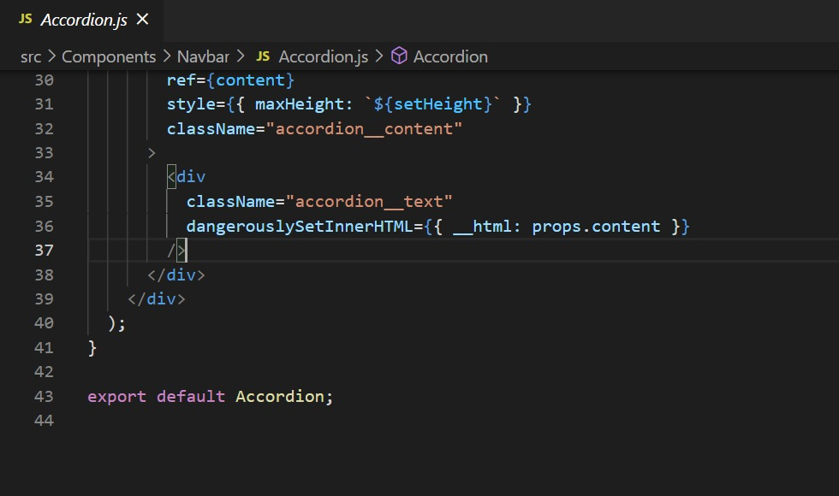

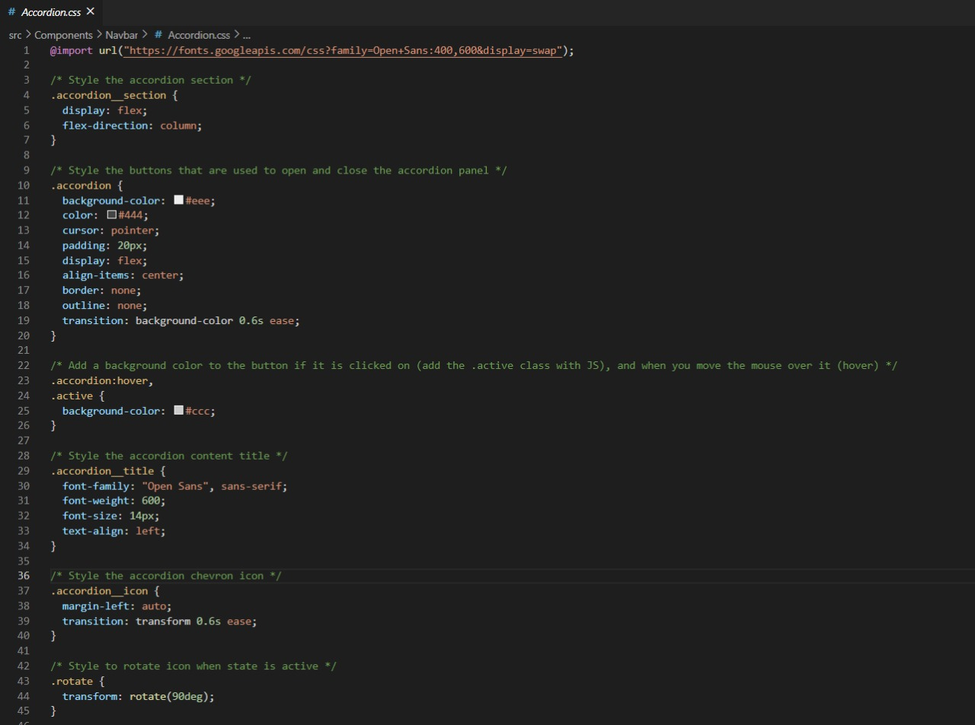

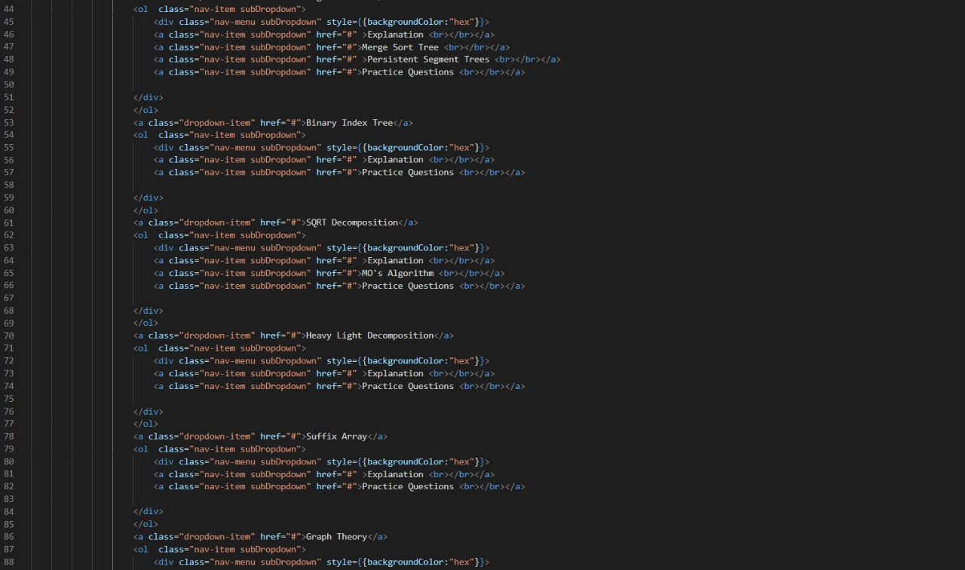

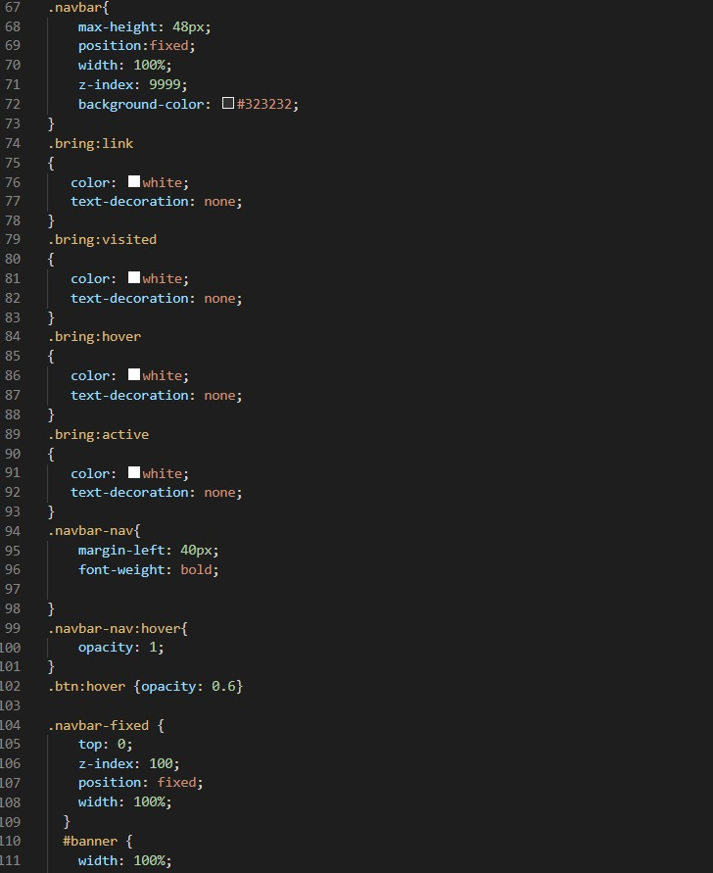

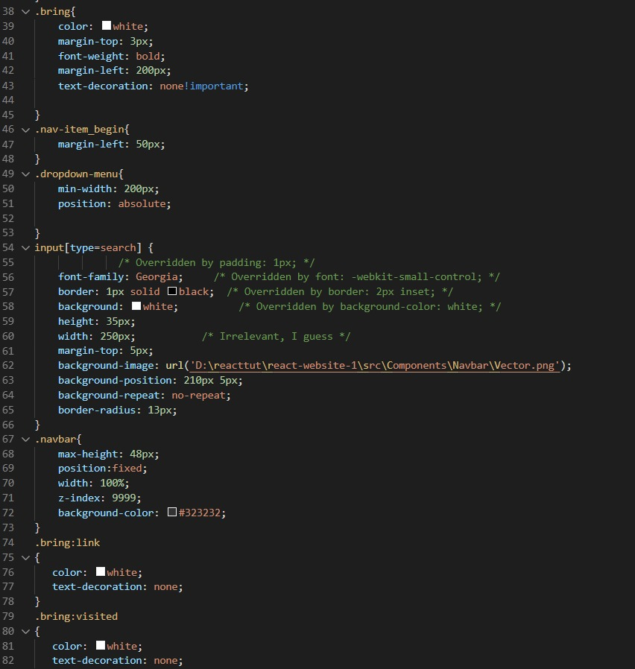

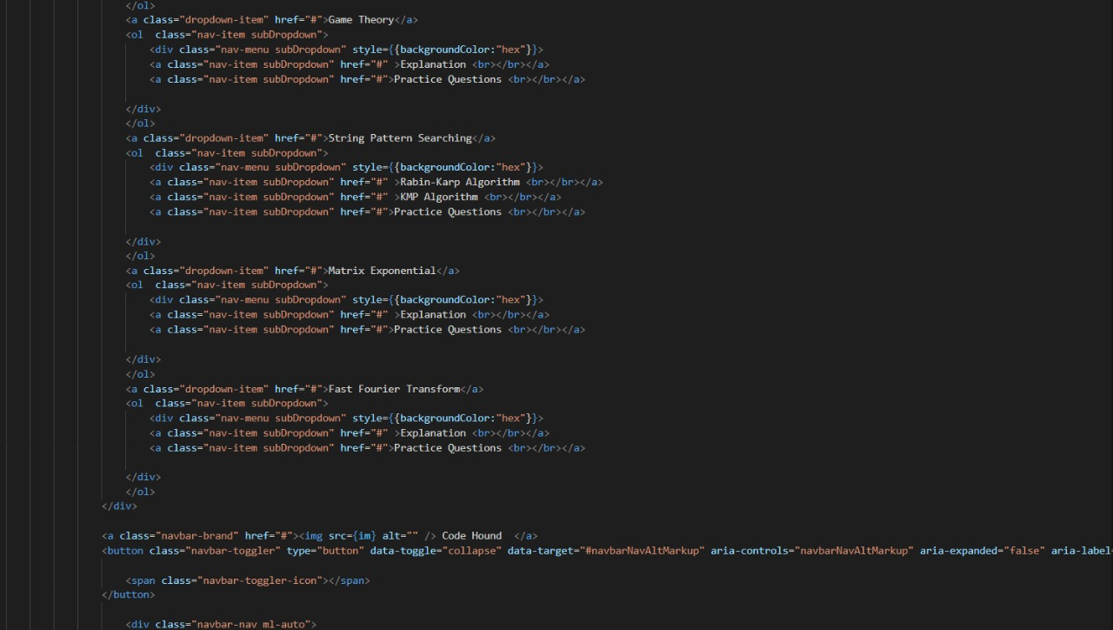

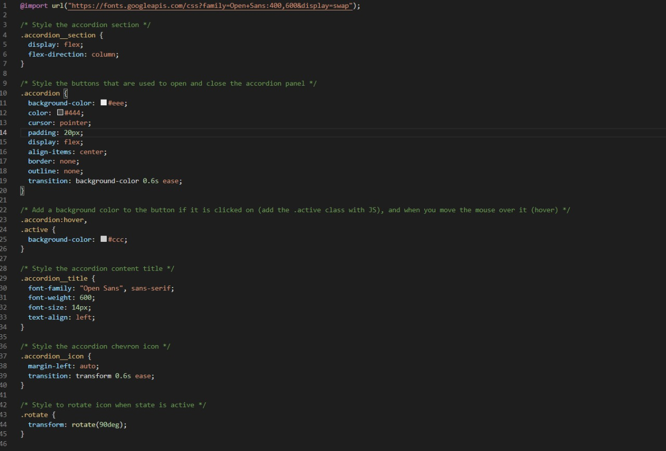

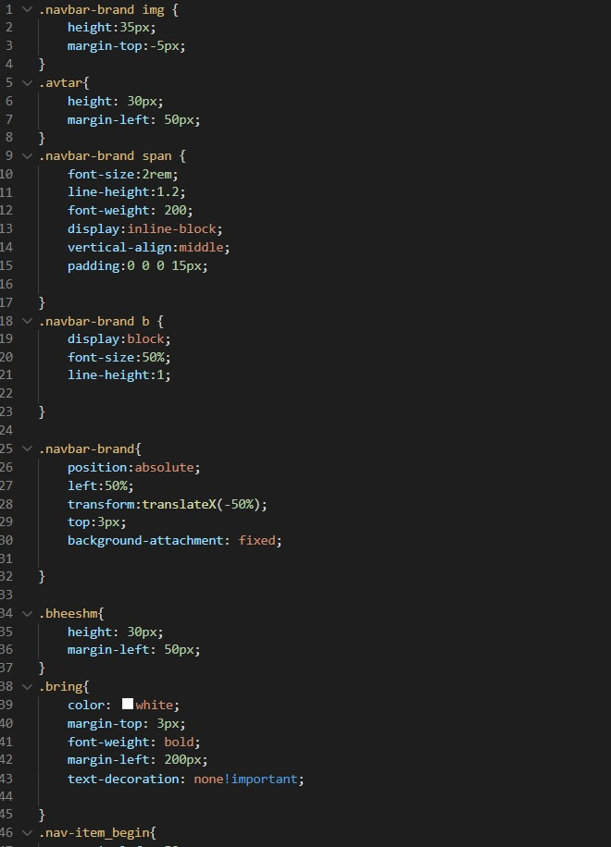

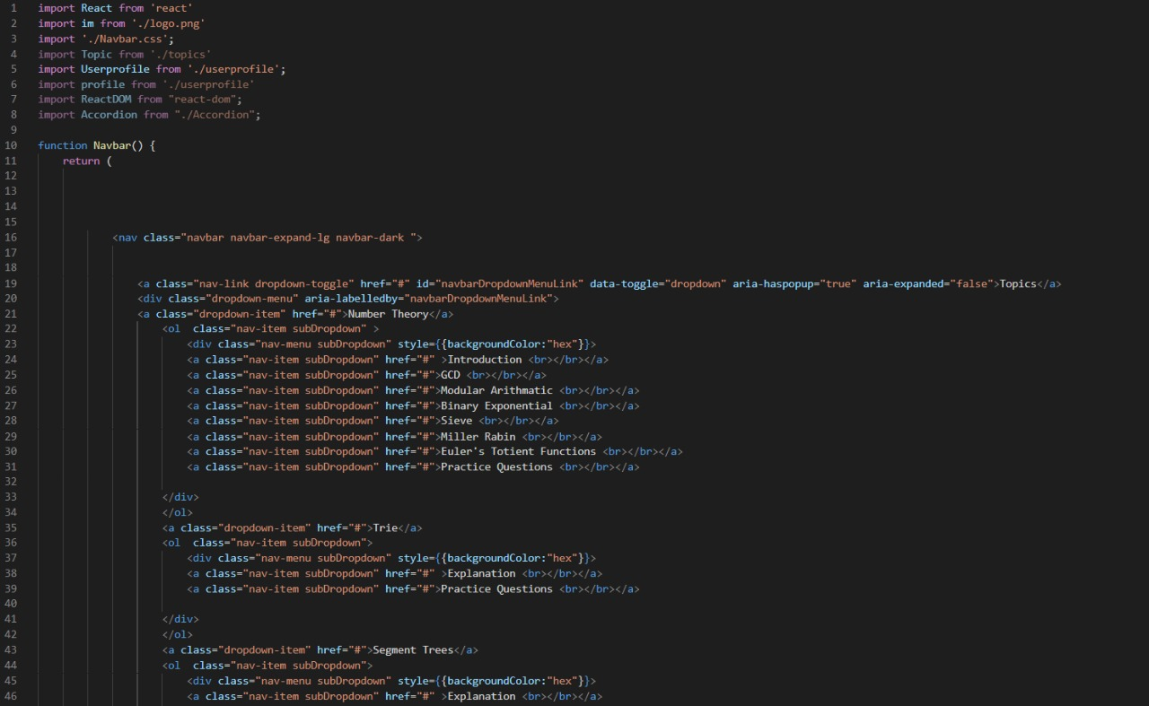

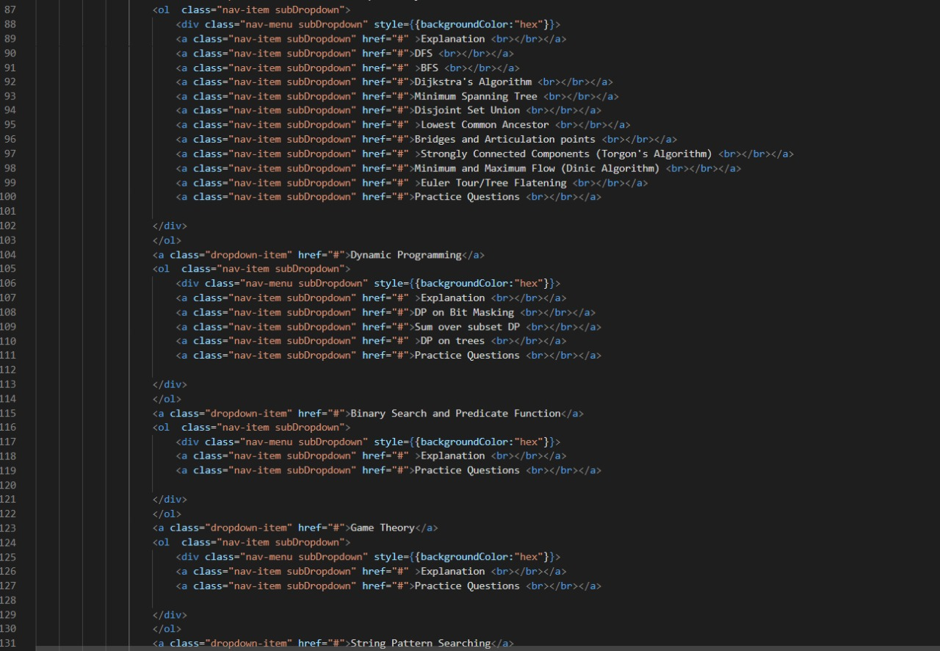

**Testing:**

Home Page-

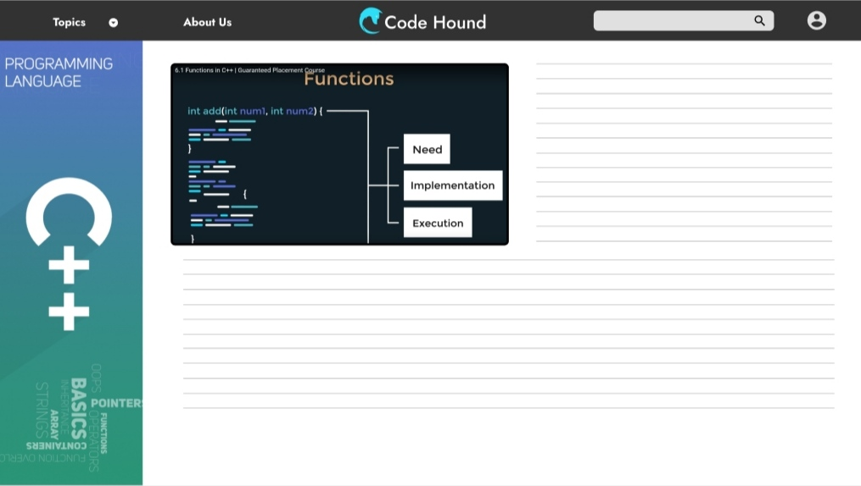

Topics-

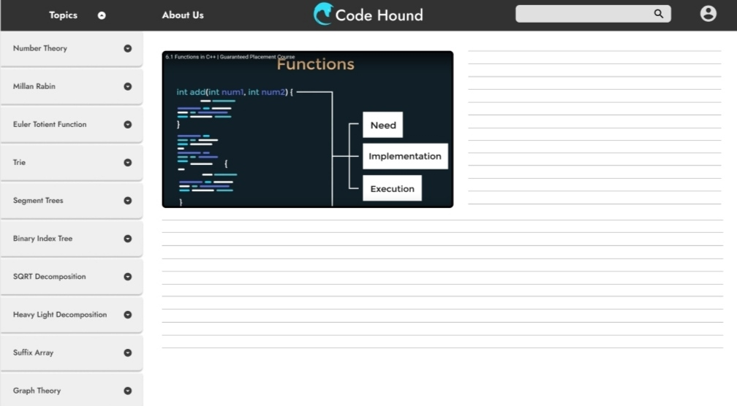

Sub-Topics-

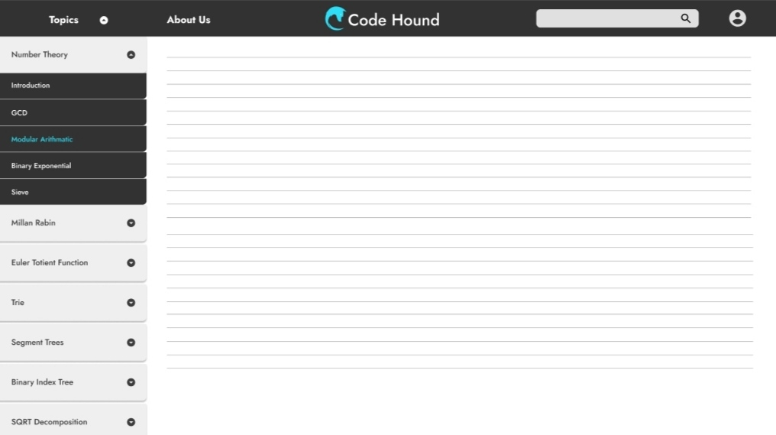

**References:**

This project is the output of work of our team members and guidance of our mentor.

But there’re some website which helped us a lot.

These are:

* [https://www.udemy/mycourses/Modern React with Redux[2020](https://www.udemy/mycourses/Modern%20React%20with%20Redux%5b2020) Update]
* <https://www.geeksforgeeks.org>
* <https://www.w3schools.com>
* <https://tutorialspoint.com>
* https://[www.youtube.com](http://www.youtube.com)
* https://[www.bootstrap.com](http://www.bootstrap.com)
* https://[www.stackoverflow.com](http://www.stackoverflow.com)